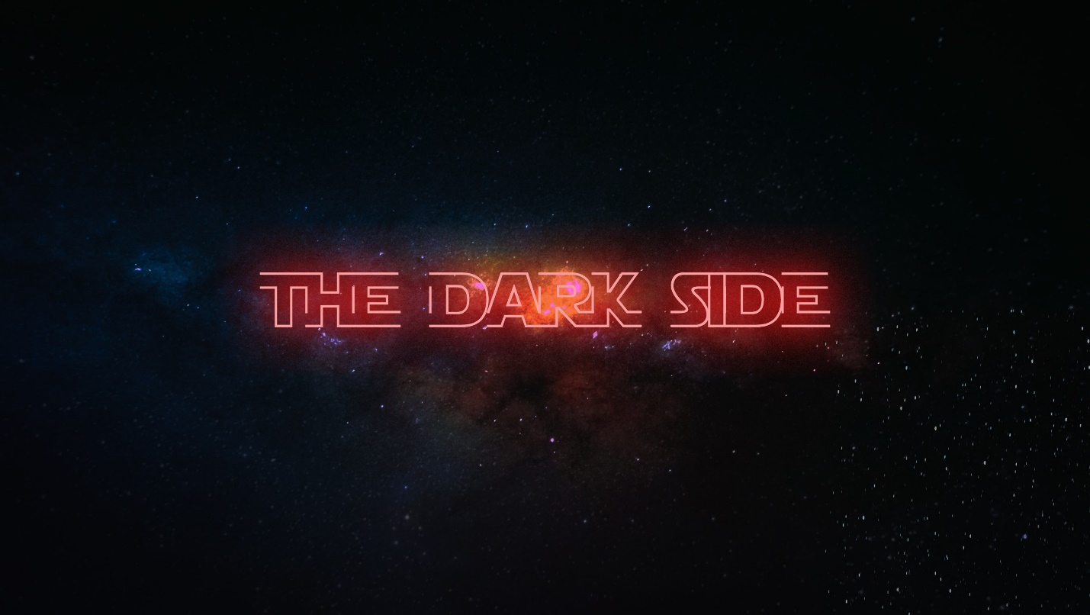**Week 3 - The Dark Side**

**LIFE/INTRO QUESTIONS (CHOOSE 1 OR 2)**

* What are some of your favorite relationships in your life right now? Friends, family, significant other?
* What fears have you experienced this week?

**CONNECTION QUESTION**

* Has there ever been a time where the fear of something made you lose relationships with someone? Explain that time.

**Sermon in a Sentence**

* Fear, if you allow it, can isolate you and kill the relationships God intends for you to have.

**SCRIPTURE**

* **Ecclesiastes 4:9-12** Two are better than one, because they have a good return for their labor: If either of them falls down, one can help the other up. But pity anyone who falls and has no one to help them up. Also, if two lie down together, they will keep warm. But how can one keep warm alone? Though one may be overpowered, two can defend themselves. A cord of three strands is not quickly broken.
* What is Jesus saying in this scripture?

**DISCUSSION QUESTIONS**

* Where are some areas in your life where you are isolated or where you feel isolated?
* Do the people in your life hold you accountable? If yes, how do they hold you accountable? If no, do you think that those are healthy relationships to be in?
* Do you keep your failures and hurts hidden? Why or why not?

**LIFE APPLICATION**

We want students walking away with 1 or 2 things they are going to do SOON to apply what they discussed.

* If you keep your hurts and failures hidden, what are some steps you can take to open up about those so the Devil doesn’t tear you down.

**TAKE IT OUT**

* Close small group out with prayer requests.
* Remind your students that Fusion is next month – they need to go to fusion.events to register!
* Refuse to let money stand in the way – check FPSLeaders.com for a scholarship application if needed.